The doctrine of Heavenly Mother is uniquely ours, uniquely recent, and uniquely “great and important.” The Gospel Topics Essay about Her states that “the doctrine of a Heavenly Mother is a cherished and distinctive belief among Latter-day Saints.” With Her in mind this coming year as we focus on the shared stories of Christianity in the New Testament, let us celebrate Her in the creation of humankind, the creation of this miraculous world, and when describing the nature of God.

Here are a few quotes and resources we have amateurly collected for you to use in your primary lessons as you see fit:

“All human beings are children of loving heavenly parents and possess seeds of divinity within them.”

*Becoming Like God*, Gospel Topics Essay

“Logic and reason would certainly suggest that if we have a Father in Heaven, we have a Mother in Heaven. That doctrine rests well with me.”

Gordon B. Hinckley, “Daughters of God,” General Conference, 1991.

“Eloheim is from the word Eloi, God, in the single number; and by adding the word heim, it renders it Gods.”

Joseph Smith, *Teachings of the Prophet Joseph Smith*, p. 371.

“God is our father. He loves us. He and our mother in heaven value us beyond any measure. They gave our eternal intelligences spirit form, just as our earthly mothers and fathers have given us mortal bodies. Each of us is unique – one of a kind, made of the eternal intelligence that gives us claim upon eternal life.”

Spencer W. Kimball, *My Beloved Sisters*, p.25

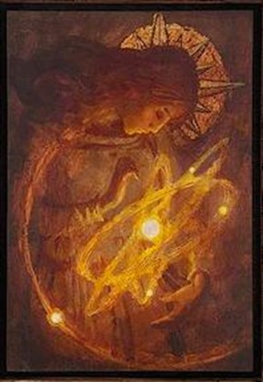

“All of us commenced a wonderful and essential journey when we left the spirit world and entered this often-challenging stage called mortality. The primary purposes of our existence upon the earth are to obtain a body of flesh and bones, to gain experience that could come only through separation from our heavenly parents, and to see if we would keep the commandments. In the book of Abraham chapter 3 we read: “And we will prove them herewith, to see if they will do all things whatsoever the Lord their God shall command them.”

Thomas S. Monson, “Ponder the Path of Thy Feet,” General Conference, 2014.

J. Kirk Richards, *Mother Creator*

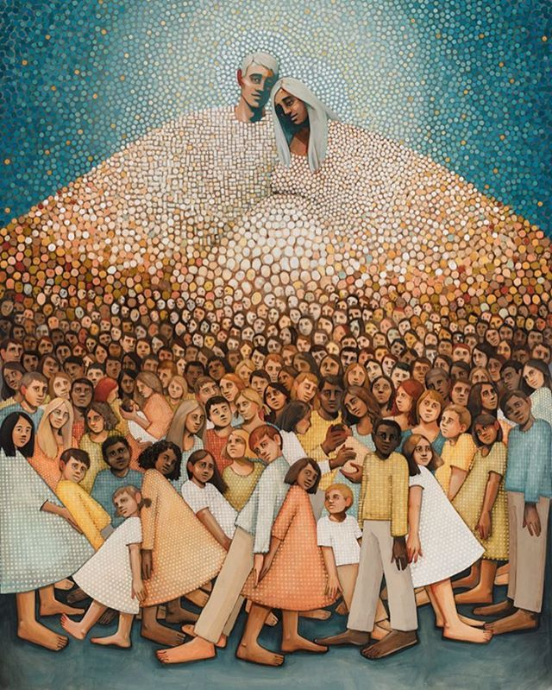

Caitlin Connolly, *In Their Image*

“Everyone, before coming to this earth, lived with Heavenly Father and Heavenly Mother, and each was loved and taught by them as a member of their eternal family.”

M. Russell Ballard, *Our Search for Happiness*, 1993.

“Our heavenly parents provided us with a celestial home more glorious and beautiful than any place on earth. We were happy there. Yet they knew we could not progress beyond a certain point unless we left them for a time. They wanted us to develop the godlike qualities that they have. To do this, we needed to leave our celestial home to be tested and to gain experience”

*Gospel Principles*, 1978, p. 13.

“This divine entreaty is consistent with the fact that, as begotten children of heavenly parents, we are endowed with the potential to become like them, just as mortal children may become like their mortal parents.”

Russell M. Nelson, “Perfection Pending,” General Conference, 1995.

“Trees reach up for the light and grow in the process. So do we as sons and daughters of heavenly parents. Facing upward provides a loftier perspective than facing right or facing left. Looking up in search of holiness builds strength and dignity as disciples of Deity.”

Russell M. Nelson, “Thou Shalt Have No Other Gods,” General Conference, 1996.

“All men and women are in the similitude of the universal Father and Mother, and are literally the sons and daughters of Deity.”

First Presidency, Joseph F. Smith, John R. Winder, Anthon H. Lund; “Messages of the First Presidency,” 4:203.

“To Mother Eve, to Sarah, Rebekah, and Rachel, to Mary of Nazareth, and to a Mother in Heaven, I say, thank you for your crucial role in fulfilling the purposes of eternity.”

Jeffery R. Holland, “Behold Thy Mother,” General Conference, 2015.

“You are daughters of God. You are precious. You are made in the image of your heavenly Mother.”

Spencer W. Kimball, 1982, *Teachings of Spencer W. Kimball*, p. 25.

“Our theology begins with heavenly parents. Our highest aspiration is to be like them.”

Dallin H. Oaks, “Apostasy and Restoration,” General Conference, 1995.

“You are a son of God. You lived in a premortal existence as an individual spirit child of heavenly parents.”

Boyd K. Packer, “Counsel to Young Men,” General Conference, 2009.

“You have light because you are literally spirit daughters of Deity, “offspring of exalted parents” with a divine nature and an eternal destiny. You received your first lessons in the world of spirits from your heavenly parents.”

Julie B. Beck, “You Have a Noble Birthright,” General Conference, 2006.

**Abraham 4:26**. And the Gods took counsel among themselves and said: Let us go down and form man in our image, after our likeness; and we will give them dominion over the fish of the sea, and over the fowl of the air, and over the cattle, and over all the earth, and over every creeping thing that creepeth upon the earth. **27.** So the Gods went down to organize man in **their** own image, in the image of the Gods to form they him, **male and female** to form **they them**.

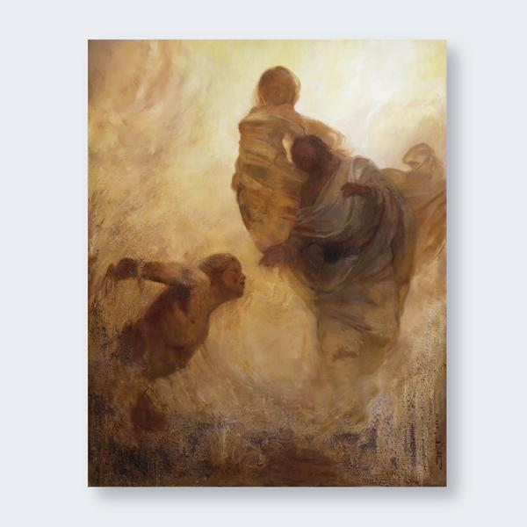

“And so the first man, Adam, and the first woman, Eve, were formed and given bodies that resembled those of our Heavenly Parents.”

*Gospel Principles*, 1978, p. 28.

J. Kirk Richards, *Breath of Life*

“Our Heavenly Parents’ love and concern for us continues to this very moment.”

M. Russell Ballard, qtd. in “A Mother There,” 1992.